Adobe has added POINT COLOUR in the latest edition of Lightroom. This tool is also in Adobe Camera Raw which ships with Photoshop. Both tools work in exactly the same way.
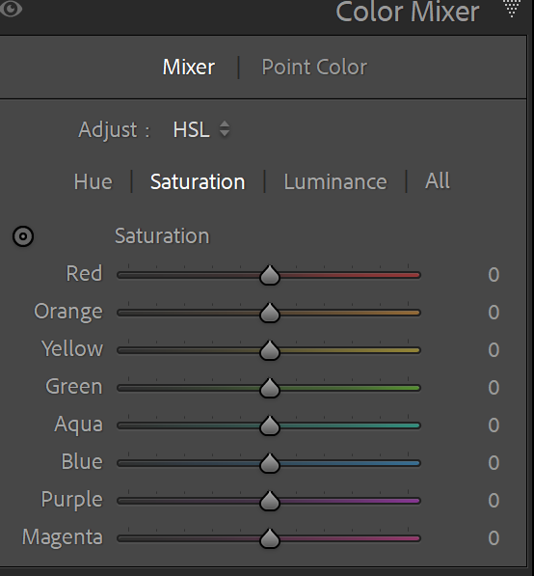
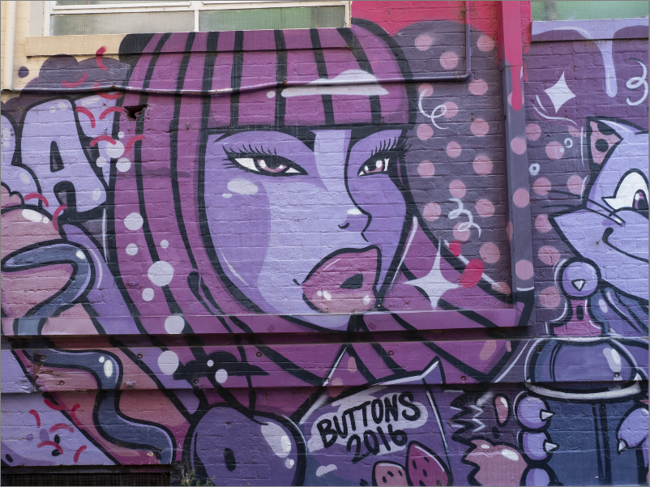
Previously the colour mixer was the tool to adjust the hue, saturation and luminance of a colour. The problem though was that the effect was global and also the colour mixer was not available in masks. This problem is solved using the new Point Colour tool.
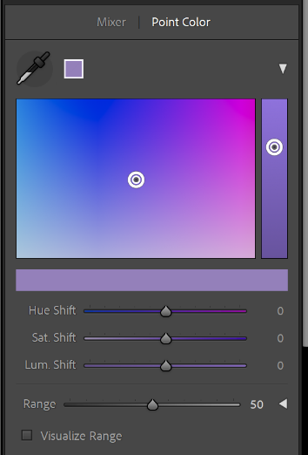
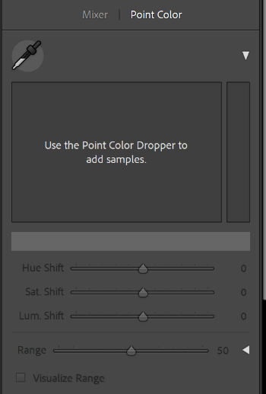

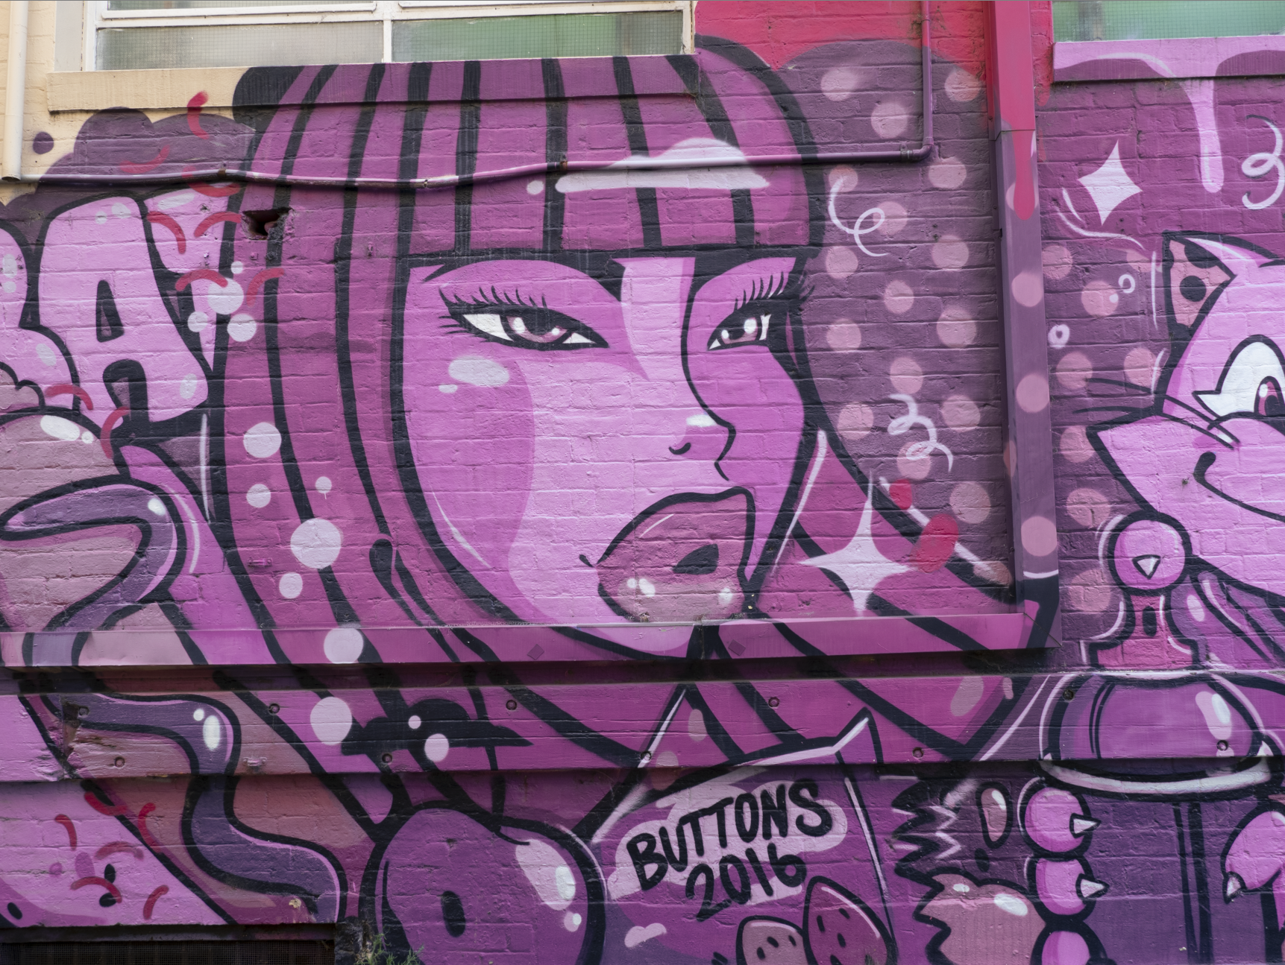

Using the point colour target tool (the knife) on our image, we may sample a colour. I have sampled the colour of the cheeks in our image. The point colour displays the selected colour with a small circle in the square and also in the side strip. The square is used to manipulate the hue and saturation, while the side bar on the right may be used to adjust the luminosity of the colour. The bar underneath the square will depict the starting colour and the final colour.

Adjustments may also be made using the three sliders – the hue sift, the saturation shift and the luminosity shift.
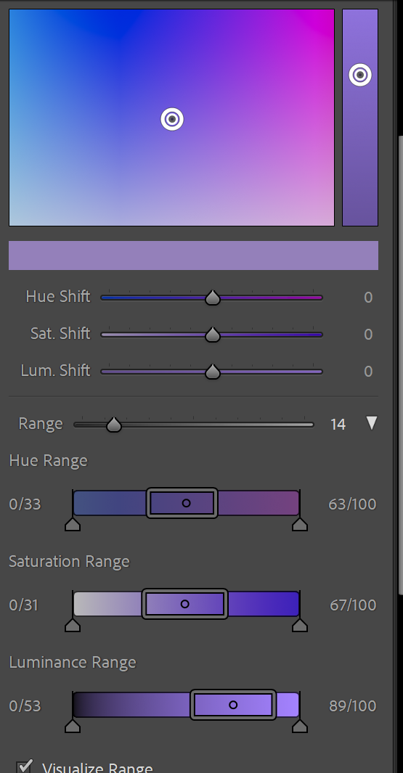
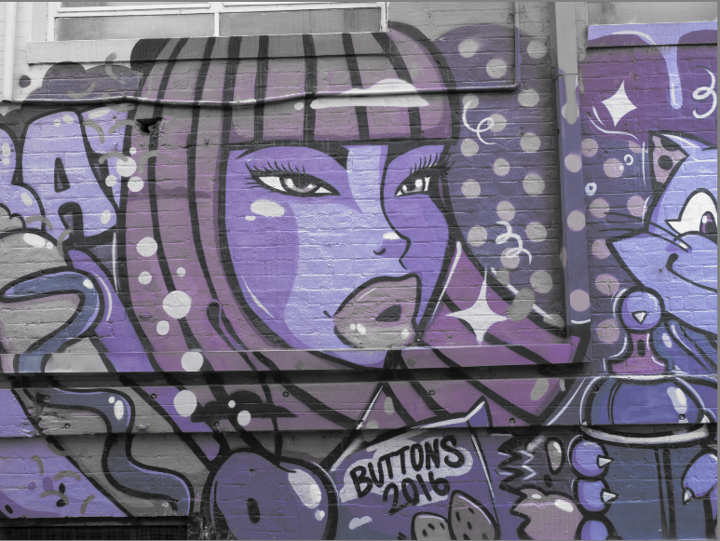
Checking the Visualise Range box gives a depiction of what will be affected. White and grey areas will not be affected. Coloured areas will be affected.

The Range slider allows us to target the actual colour more accurately. When using this slider, the range of colours affected will display in the square.

Clicking on the triangle on the right of the range slider opens three more sliders that may be adjusted to further isolate the colour.

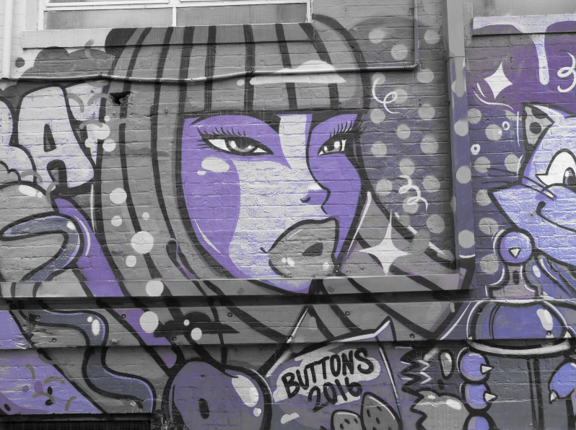
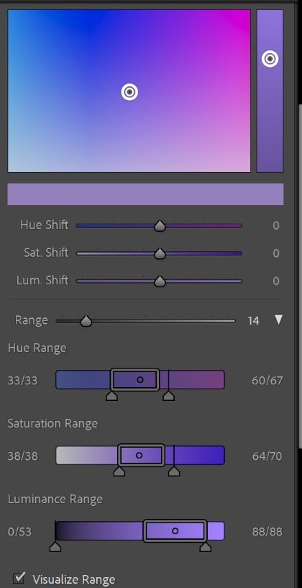
Here the Hue has been confined to the colour range indicated by the rectangle as has the saturation and luminance. This means that there is no fall off either side of these rectangles.
Now with the visualise range box still checked it is possible to see what will be altered. Below the colour has been moved towards the blue. Note that in the large square you see two circles in the square. The smaller circle indicates the original selected colour.

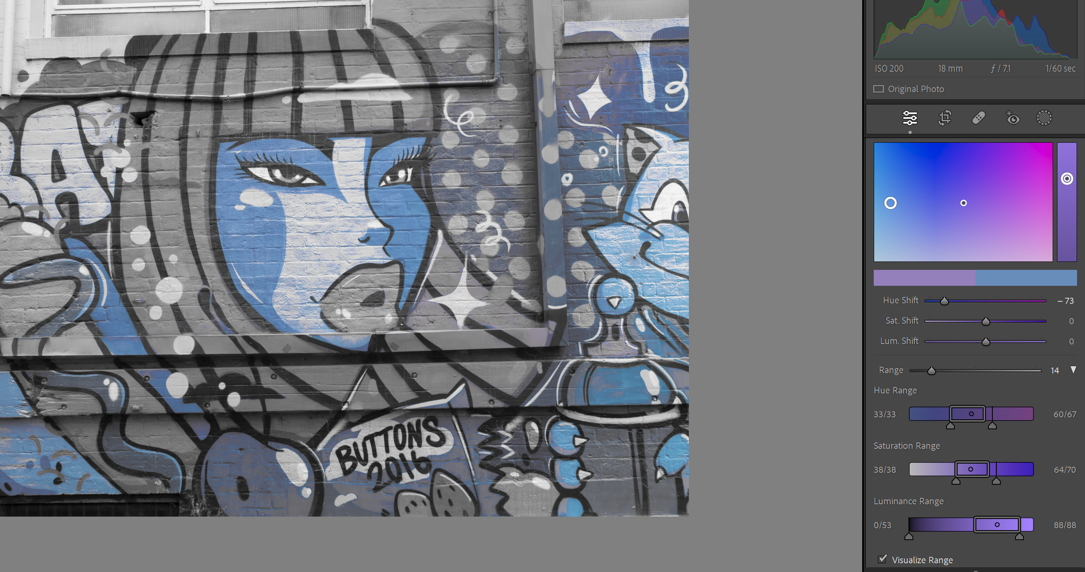

With the visualise range check unchecked the full effect of the point colour adjustment may be seen.
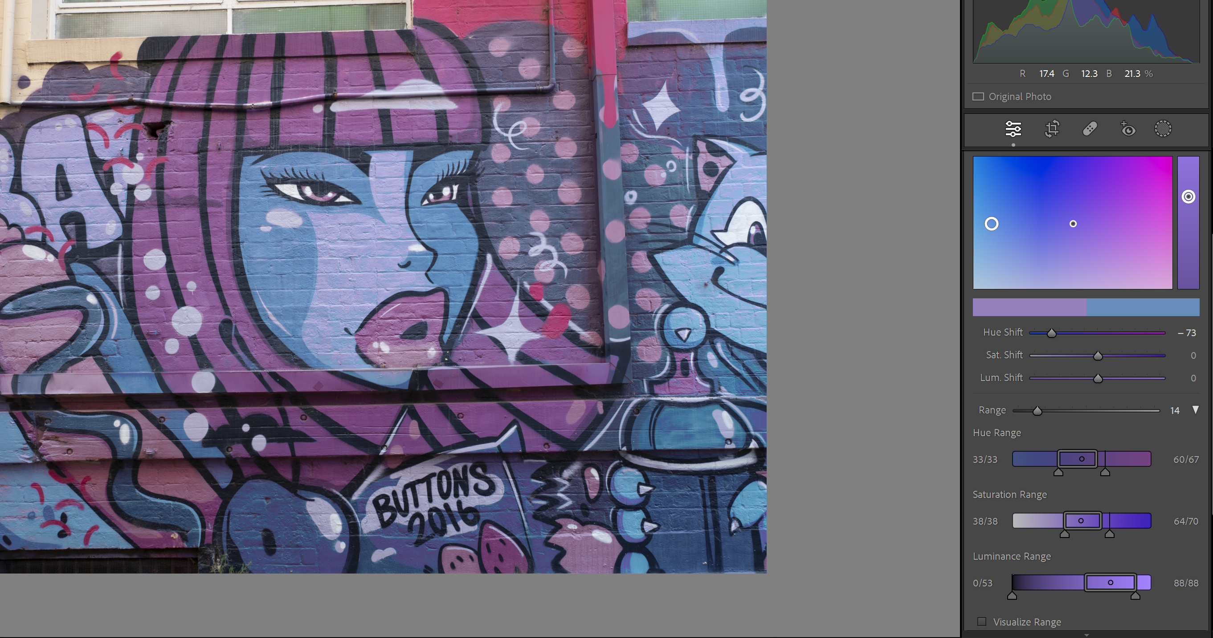

MASKING AND THE POINT COLOUR ADJUSTMENT.
The point colour tool is available now with masking. This enables even further isolation and is a local adjustment not a global one.

