PHOTOGRAPHY MASTERCLASS No 1 Blending texture(s) and images

I am hoping to teach Photoshop through a series of projects. For this first lesson, we will learn how to blend images and textures. There will be something for each level.
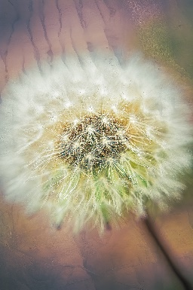
For Beginners:
Opening an image into Photoshop.
Introduction to layers
Opening a texture into Photoshop as a layer
Introduction to Blend Modes.

For Others:
As above
Clipping masks in Photoshop layers
Selecting a colour from the texture
Retaining the subject’s density and opacity
Black and white adjustment layer to remove colour in a texture.
Merged layer – Ctrl+Shift+Alt+E (windows) Cmd+shift+Opt+E (Mac)

Advanced:
As above
Gradients
Colour Lookup Tables

