LIGHTROOM TRAINING

  - Lesson 3 Exploring Colour
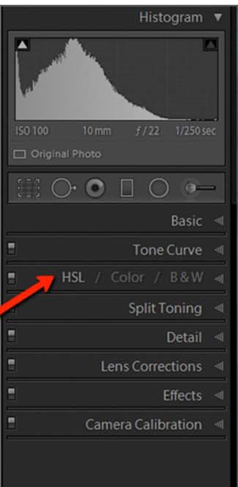
The Lightroom HSL Panel:
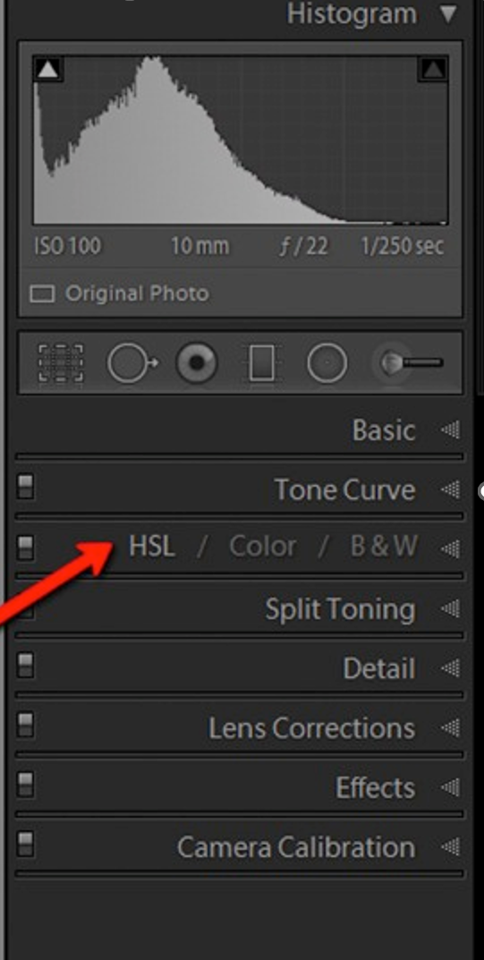

The HSL Panel enables you to adjust
- The hue (colour)
- The saturation (intensity of colour)
- The Luminance (colour brightness)

This panel allows you to control different colours independently. You can adjust the hue, saturation and luminance of targeted colours.

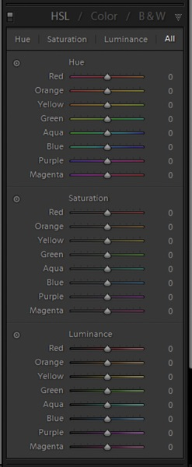
Hue adjustments
There are eight hue sliders. By moving the sliders, you can change the colour hues. Each hue slider affects only that colour. Image saturation or luminance are not affected by the hue slider.
Three main uses for the hue slider:
- to more accurately represent what you saw the moment you took the photo.
- to give colours specific artistic looks e.g. Darker blue skies.
- to create specific colour combinations. You simply use the colour wheel to identify two colours that look good together, then you shift the Hue sliders until you get the result, you’re after.

Saturation adjustments
Saturation refers to colour intensity, so by boosting colour saturation, you’ll end up with eye-popping, vivid greens, reds, and blues. On the other hand, by reducing colour saturation, you’ll end up with more subdued, faded greens, reds, and blues.
Specific colours are targeted and so you can desaturate one colour and saturate a different colour.
Saturation is useful for:
- to make your photo truer to life. RAW files tend to look undersaturated, so by boosting specific colours, you can recreate the scene as you remember it.
- Artistic looks. You might make one or two main colours pop while letting the others recede. Desaturating distracting background colours while saturating interesting foreground colours, you can help focus the viewer on the main subject.
- to help achieve specific colour palettes. Simply desaturate the colours that do not conform to your desired colour palette, and you’re good to go! (

Luminance adjustments
The Luminance sliders target brightness values for specific colours. Boosting the blue slider, the blues become brighter; reduce the green slider, and the greens become darker etc.
Luminance adjustments are especially effective for creating contrast in an image. For instance, you can boost the luminance values of subject colours while reducing the luminance values of background colours. That way, your subject will pop off the screen while the background recedes.
You can also use luminance adjustments to handle image distractions. If you darken down distracting colours, you can simplify the shot and effectively focus the viewer. (That’s why it’s always a good idea to do a “distraction check” while editing! Identify any distracting elements, then use the Luminance sliders to make them recede.)

Using the target icon to make HSL Adjustments
First, click the target icon next to either the Hue, Saturation, or Luminance sliders:
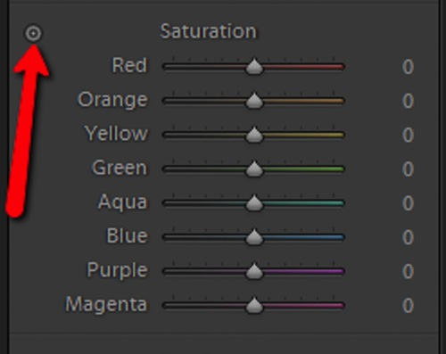
Identify the area of your image that you wish to adjust. Click and drag the cursor over this area. Dragging upwards increases the corresponding colour slider and dragging downwards reduces the colour slider’s effect. This target icon is available for hue, saturation and luminance adjustments.

Acknowledgment: This material has been adapted from – Adam Welch
https://digital-photography-school.com/understanding-the-hsl-panel-in-lightroom-for-beginners/

The Colour Grading Panel
The Colour Grading Tool is used to introduce a specific colour into your photos. This colour can be added in areas, such as the shadows, midtones or highlights, or globally across the image. With the help of two additional sliders, you can adjust exactly how it’s applied.

Tool Layout & Overview
The Colour Grading Tool is located in the development module directly beneath HSL/Colour. Click on the tab to expand the panel to find the default tool layout. Here you see five small icons, three colour wheels with a slider beneath each, and a Blending and Balance slider at the bottom.
Adjust Icons
The first feature comes in the shape of 5 smaller icons, all circular and representing a wheel. These icons serve as buttons and change the beneath layout based on which tones you want to target:
- 3-Way is the default layout where you can adjust the Midtones, Shadows and Highlight colour wheels
- Shadows displays the colour wheel targeting the shadows
- Midtones displays the colour wheel targeting the midtones
- Highlights displays the colour wheel targeting the highlights
- Global reveals a colour wheel that affects the entire image, regardless of its luminosity

It is best to use the individual colour wheels as the 3 way layout is too small for accurate working.

Colour Wheels
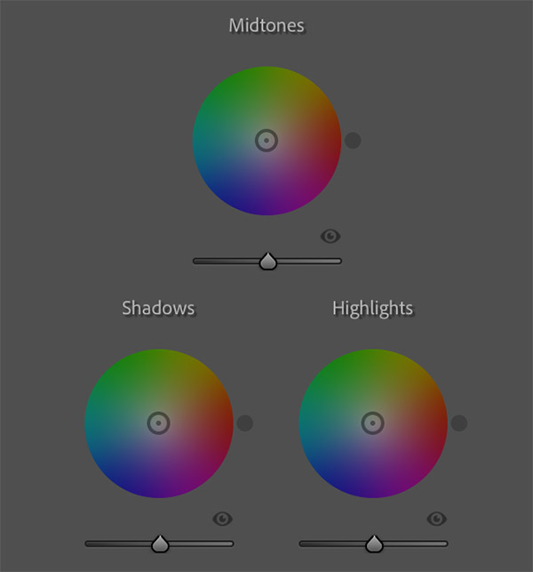
The wheels, or circles, are used to introduce colours of different hues and saturation and luminance to specific parts of your images. Inside each colour wheel, you will see a small circle - you just need to click and drag it to start colour grading.
- Moving the small circle clockwise or counter-clockwise will change the hue.
- Moving the circle towards the centre or the outside will adjust the saturation.
- Moving the slider underneath each colour wheel will adjust the luminance.

There’s also an eye icon to toggle the effect on/off and a Luminance slider found beneath each wheel. The Luminance slider is used to increase the brightness of the selected colour.

Blending & Balance Sliders
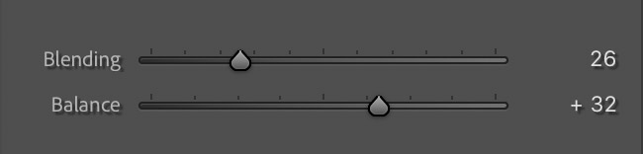
The Blending slider controls how much of the shadows, mid-tones, and highlights blend together.

The Balance slider determines whether shadows or highlights are more dominant.
- If you drag the slider to the right, you will see more tint from the highlights.
- If you drag the slider to the left, you will see more tint from the shadows.

Blending and balance sliders affect the image globally

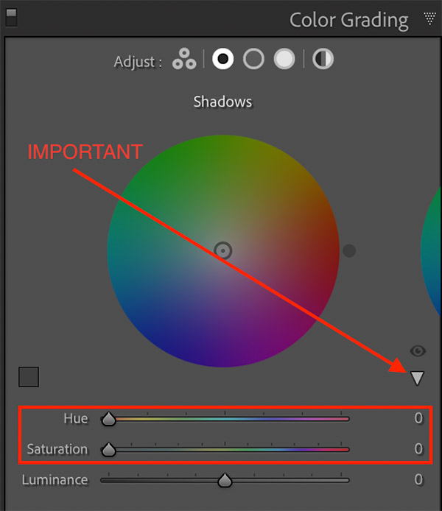
The Hidden Hue & Saturation Sliders

There are two more sliders - a hue and a saturation slider the Hue and Saturation sliders. These are opened by clicking on the arrow under the eye icon when you are using the individual colour wheels. They are useful for fine tuning adjustments.

The last icon at the top of the colour Grading Tool is the global colour wheel, which can be used to change the tint of the entire image. If you are only looking for a simple colour grading effect, you can use this global wheel as your primary tool. You can also use it as a final adjustment after making individual changes.

Why use Colour Grading?
- To recreate the beautiful warm tones of the golden hour.
- For mood and feeling.
- To help the viewer understand more about the scene.
- To reinforce seasonal colours such as spring and fall.
- To give a consistent look to a series of images.
- For associating colours with a particular photographic genre or style (consider the matrix film with its green tones or the orange-blue tones of many other films).

Keyboard shortcuts for the colour wheel

Use the following keys while dragging the colour wheel’s small circle:
- Option (Mac)/Alt (Windows): Makes the controls less sensitive and easier to use for accurate results.
- Shift: Adjusts only the Saturation.
- Command (Mac)/Ctrl (Windows): Adjusts only the Hue
It’s also possible to increase the Hue/Saturation using the same keyboard combinations as with other sliders (i.e., Option/Alt + Up = increase Saturation with 1 or Option/Alt + Shift + Up = increase Saturation with 10)

Material adapted from Christian Hoiberg
https://www.capturelandscapes.com/color-grading-tool-in-lightroom/
and Ana Mireles
https://www.lightroompresets.com/blogs/pretty-presets-blog/color-grading-tool-lightroom

Calibration in Adobe Camera Raw and Lightroom
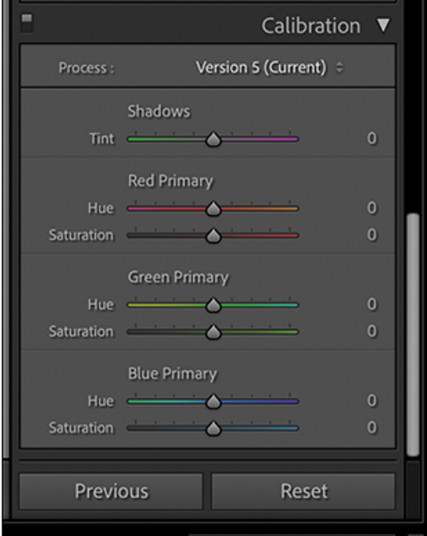
When light hits the camera sensor, it generates an electrical current that is converted into a digital signal. The red, green, and blue light-detecting sub-pixels are what’s used to calculate what colour and how bright any given pixel in your image should be. However, there’s no universal standard for what electrical charges equal what colours. Different camera manufacturers convert the digital signal into the colours in your image in slightly different ways. This is a big part of why different cameras all have a unique look, and it’s largely the reason that two people standing side-by-side but using different cameras will get slightly different looking RAW photos.

The Calibration panel enables you to change the underlying colour assumptions in the whole image. It works best with RAW images and is a lot less effective on JPEGs as there is less data to work with

Using the Calibration Tool
The Shadows Tint slider enables you to remove any colour cast in the dark areas of your image without affecting the rest of the colours. If the shadows look a bit too green, drag it to the right to add more magenta. If things look too red or magenta, drag it to the left to add more green.

The Red Primary, Green Primary, and Blue Primary options are the main tools in the Calibration panel. Each has a Hue slider and a Saturation slider.
The Hue slider shifts how every underlying colour value in the image is rendered. This means adjusting the Blue Primary Hue slider doesn’t just affect the blues in your image, but every colour that includes a bit of blue (which is most of them). It’s the same with the Red Primary Hue and Green Primary Hue sliders.

Similarly, the Saturation slider affects the intensity of every underlying colour value in the image. Increase the Blue Primary Saturation and the intensity of the blues in every pixel in the image is increased. It is the same for Red Primary Saturation and Green Primary Saturation.

The two main uses for the Calibration tools are colour correcting and colour styling. It’s so powerful because of how it affects every pixel in your image at once. This enables you to make big global adjustments that you can’t with other tools.

- For colour correcting, you use the Hue and Saturation sliders in the Red Primary, Blue Primary, and Green Primary tools (and maybe the Shadows Tint slider) to tweak colours so they look better or more natural. If there’s a lot of blue-ish artificial light in your image, for example, you can decrease the Blue Primary Saturation or push the Blue Primary Hue slider to the left towards turquoise.

- For colour styling, you can basically do whatever you want. Play around with all the sliders and see how they affect your images. Increasing the Blue Primary Saturation, for example, can make everything pop in a really cool way.

Acknowledgment:
Material from Harry Guinness
https://www.howtogeek.com/748899/what-is-calibration-in-adobe-camera-raw-and-lightroom/

THE TONE CURVE

There are two different curves within the Tone Curve panel – the Parametric and the Point curve. While both curves can be used to make adjustments to the tonal values in an image, (& contrast), the Point Curve can also be used to change colour values.

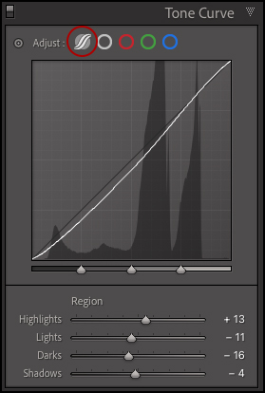
The Parametric Curve —Use the icon across the top of the Tone Curve panel to select the Parametric Curve.

Click -drag up/down on the Parametric curve to lighten/darken the image or, use the Highlights, Lights, Darks, and Shadows sliders (below the curve) to make adjustments.

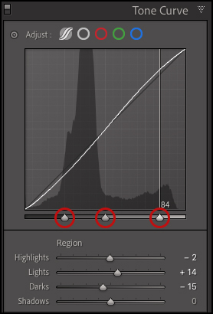
To change the tonal range affected by any of these sliders, reposition the triangles (directly under the curve).

To reset a single slider, double click its name. To reset all sliders, double click the word “Region”.

Control -click (Mac) or right-click (Win) in the Point Curve grid area to access additional options including: Reset Regions, Reset Splits, Reset Regions and Splits, Reset Curve, and Reset All.

Click the “light switch” in the upper left of the Tone Curve panel to hide/show changes made in that panel.

The Point Curve —Click the gray circle at the top of the Tone Curve panel to select the Point Curve. A maximum of 16 points can be added to the curve to make fine adjustments.
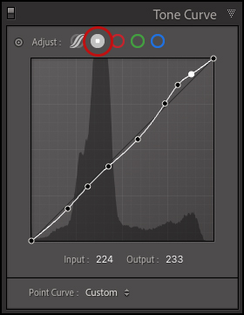
To make adjustments to the colours in an image, click the red, green and blue circles to access and adjust the individual red, green, and blue channels. When an individual channel is selected, colour gradients appear in the curve making it easier to anticipate adjustments.
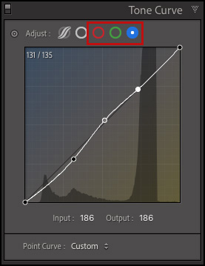

For finer control, use the Input/Output text boxes to adjust the value of any selected control point. Or, hover the cursor over a selected control point and use the up/down arrow keys to refine the adjustment.
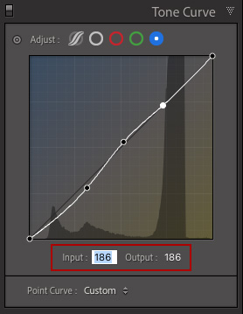

To delete individual points on the Point Curve, click -drag the point off the curve.

To reset the Point Curve, double click on the words “Point Curve”.

To Save a Custom Point Curve (to apply to other images), create the curve, then use the drop-down menu (to the right of “Point Curve”) and choose Save. Note: saving the curve to its default location will make it available in both Lightroom Classic and Adobe Camera Raw.

Control -click (Mac) | right-click (Win) in the Point Curve grid area to access additional options including: Reset Channel, Reset All Channels, Copy/Paste Channel Settings, Snap to Grid, and Show All Curves.

The Targeted Adjustment Tool —

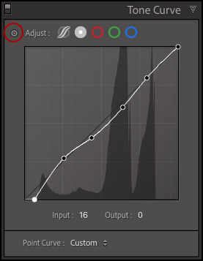
To make on-screen adjustments to the either the Parametric or Point Curve, use the Targeted Adjustment tool (the small, circular icon located in the upper left of the Tone curve panel).

Command + Option + Shift + T (Mac) / Control + Alt + Shift + T (Win) selects the Targeted Adjustment tool.

Click -drag up/down in the image preview area with Targeted Adjustment Tool to make adjustments.

Escape puts the Targeted Adjustment Tool back (while keeping changes that have been made).

To make small adjustments with the Targeted Adjustment tool, try positioning the cursor in the image preview area over the value that you want to change. Then (without clicking), use the up/down arrow keys to nudge the curve. Add the Shift key to nudge the point in greater increments.

Acknowledgment
https://jkost.com/blog/2022/03/the-tone-curve-panel-in-lightroom-classic.html

