LIGHTROOM TRAINING

  - Lesson 1 Introduction to Lightroom

Lightroom is a catalogue-based system of your images.
- It makes them easier to find.
- Lightroom does not make a duplicate of your images. It references where your images are located on your computer system.
- Lightroom does not change your image; it stores the changes you make using Lightroom into a small text file which takes up very little space on your hard drive. This means you may always access your original image. No change is ever permanent. This eliminates the need to work on duplicates. You may also use a virtual copy if you need multiple versions of an image.
- Lightroom allows you to make collections of your images (note: the collection is not another copy but a reference to where the original image is located).
- Lightroom has modules to enable various tasks such as developing your photos, printing, photobooks, maps and slideshows.
- Lightroom’s develop module enables you to process your images and all the adjustments are written into a text-based file. These adjustments are able to be copied and applied to other images, making it easy to obtain a consistent look to a series of images.
- The adjustments to colour, temperature, highlights, noise etc. may be made in any order.
- Lightroom does not use layers (Photoshop does).

Lightroom is available only on a subscription basis from Adobe. Refer to:

https://www.adobe.com/au/creativecloud/photography/compare-plans.html
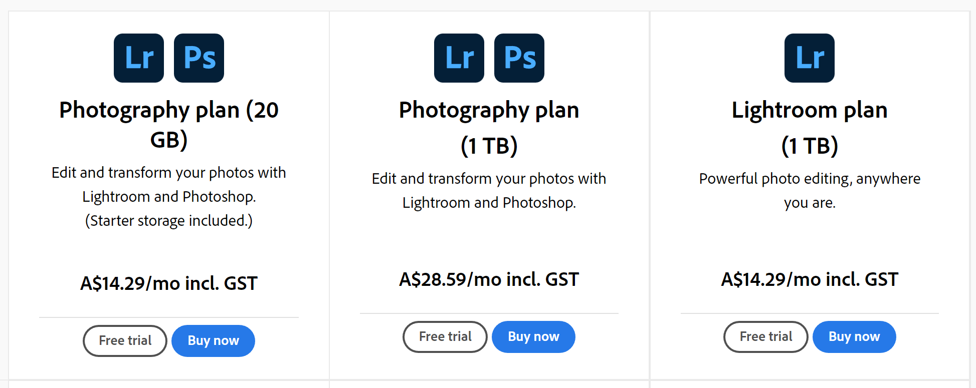

The Photography plan (20GB) gives you access to both Lightroom and Photoshop and so is good value.

There are two versions of Lightroom. The version we will use in this course is called Lightroom Classic. (The other version is imply called Lightroom and is a cloud-based system). Both versions are similar but Lightroom Classic has more features.

Organising Your Images

Your photos are best stored on an external hard drive as this way gives you room to store years of photos without taking up room on your internal drive.

Start by creating a folder and give it a name such as “MY PHOTOS”. All photos can then be stored in folders under this main folder. This makes backing up photos easier as the master folder My Photos can be copied as a whole.

File Names for images:
A suggested format: - this is taken from Ben Willmore’s system.
- Date that has a 4-digit year (2022)
- Underscore (_)
- Two-digit month
- Underscore (_)
- Two-digit date (09)
- Dash (-)
- Shoot name
- File number suffix (this is the original numbering system that the camera was using).

Folders
Your naming system will depend on how you organise your photos. Two suggestions are:
- Year_month Shoot name (If you have a good memory for dates).
- Categories – Think of what you photograph and organise folders accordingly.
Eg. Travel
Friends
People
Flowers
Animals
Competitions
Events
Etc.
You may have sub-folders within these categories.
If you already have a good system on your hard drive, then use it.

The Library Module

The Catalogue
When you first open Lightroom, you will be prompted for Catalogue details. The catalogue is merely a reference system to let Lightroom know where your files are stored. There is no limit to the number of files in a catalogue. It is best to have your catalogue on your computer rather that an external drive. Lightroom is fast enough that you need only one catalogue but if you do commercial work, then you may like to have more than one catalogue. (However, Lightroom can only read one catalogue at a time).

Once you have imported photos into Lightroom, moving, renaming or deleting images should be done through Lightroom so that the program knows where to find the images. Lightroom will allow you to just remove an image from the catalogue and hence it will still be on your hard drive, or give you the option to delete the image completely from your system.

The Lightroom Classic catalogue contains information about each image.
Image preview
Metadata
Adjustment instructions
The Lightroom Classic catalogue is contained in a .Ircat file on your computer. The image previews in the Lightroom Classic catalogue are linked to the actual images elsewhere on the computer. The catalogue only contains the images that you have added to it.

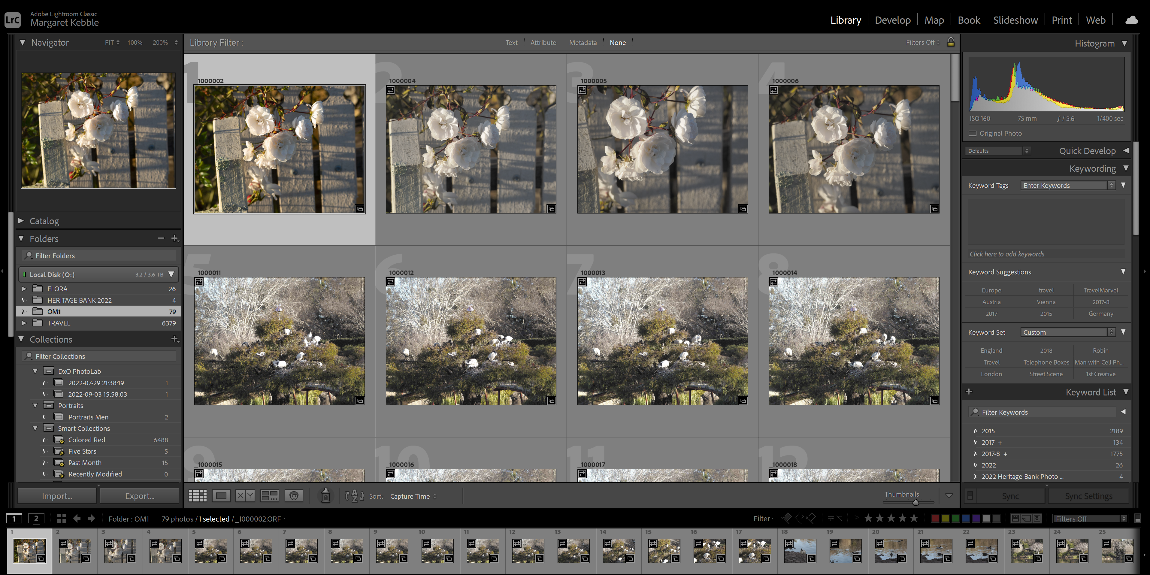
Importing Images

From the Library Module you add images to the catalogue by clicking the Import Button.

After clicking the IMPORT button you will be brought to the Import Screen. Work from left to right on this screen.

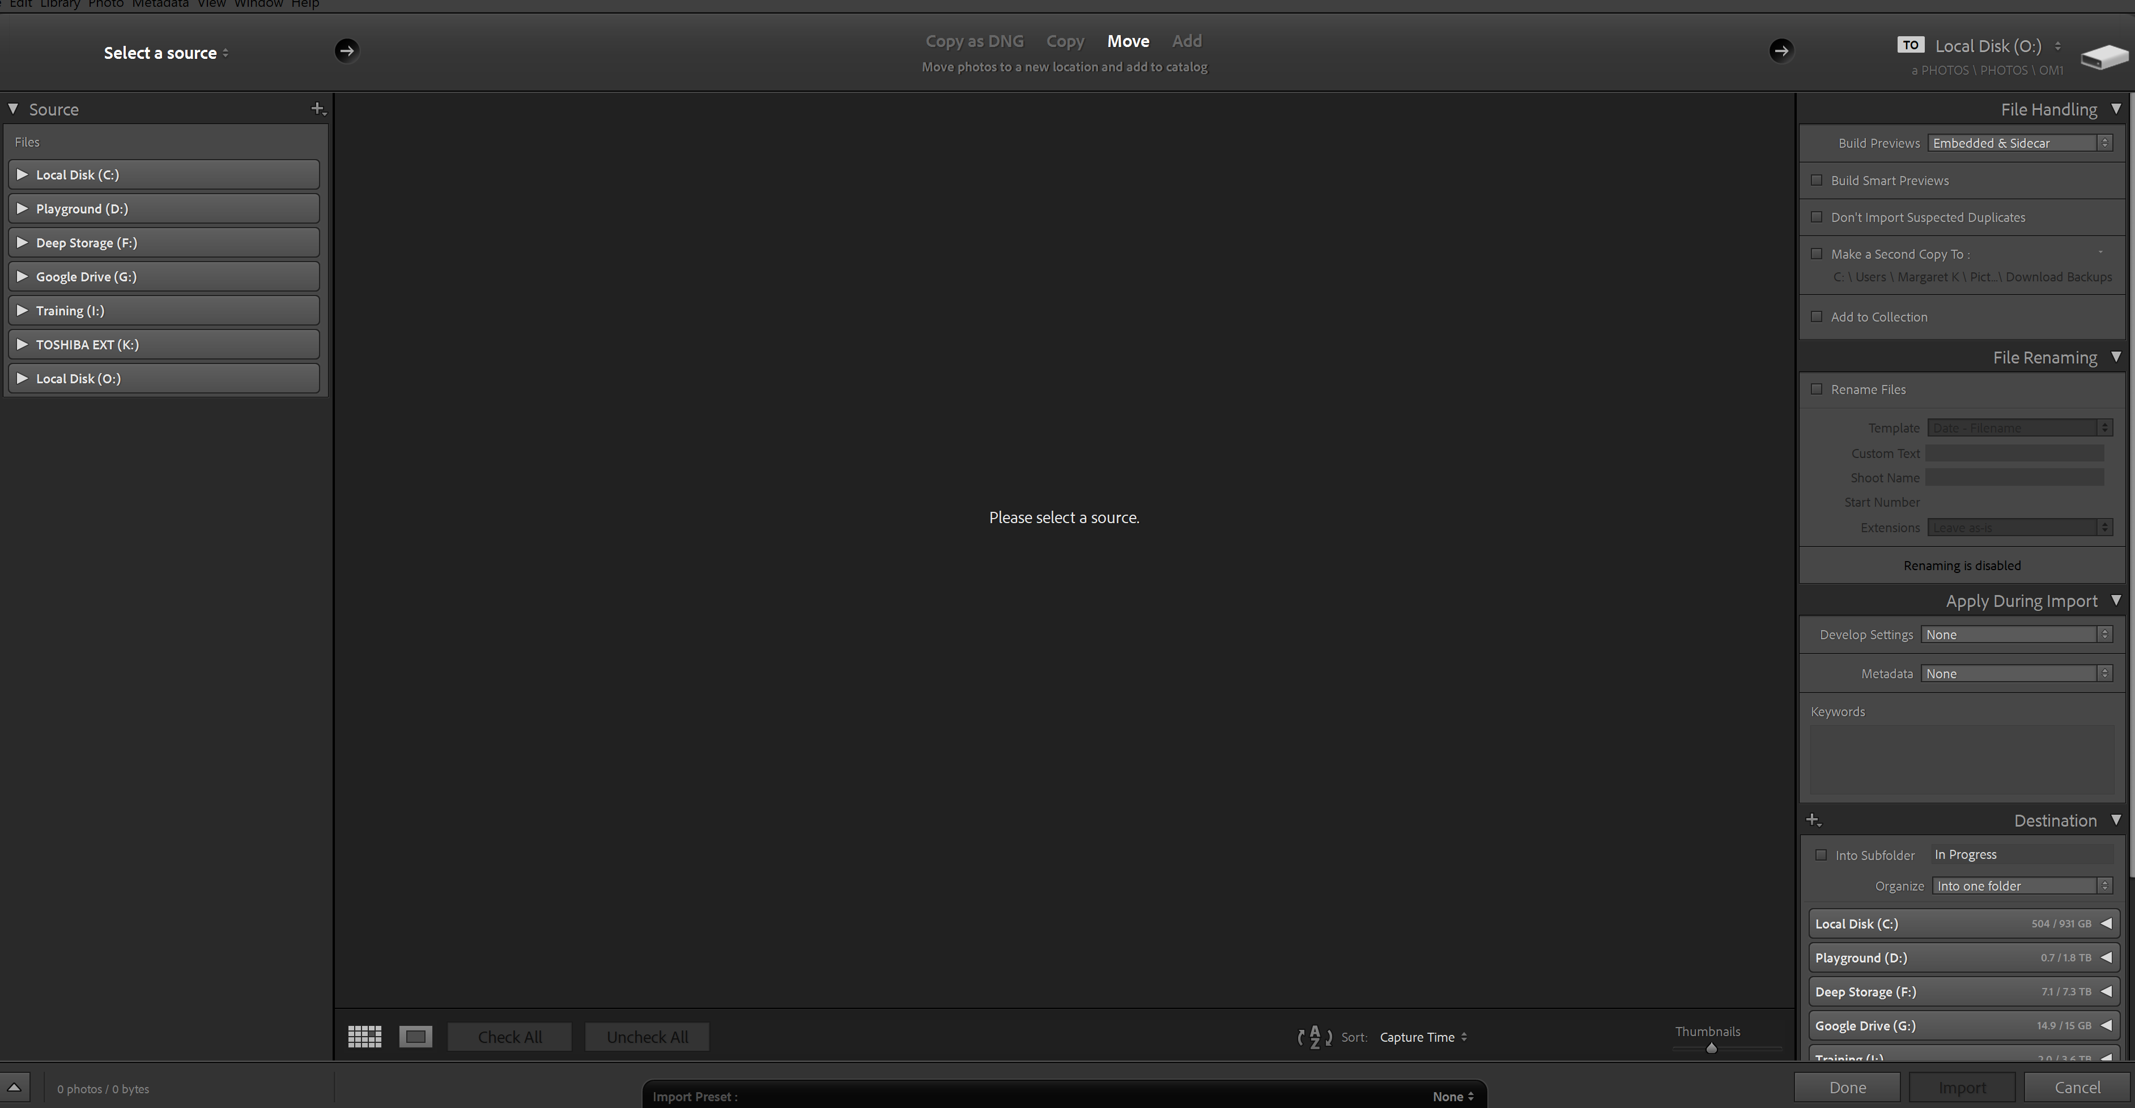

On the left choose a source where the images will be added to the catalogue from. Include sub-folders to import all images in a folder that has sub-folders.

Images from that folder and subfolders will be displayed in the middle section. Normally all images will be checked. Uncheck any images that you do not want to import.

Above the images is a bar containing choices as to how you want to import these images. The choices are
Copy as DNG
Copy (usually when you are downloading images from a memory card)
Move (when you want to move the images to a different folder)
Add (when the images are already in a folder and just need to be added to the catalogue).

The right side is very important. It sets the parameters for adding the images to the catalogue.

What you will see as options depends on whether you chose copy, move or add in the middle section.

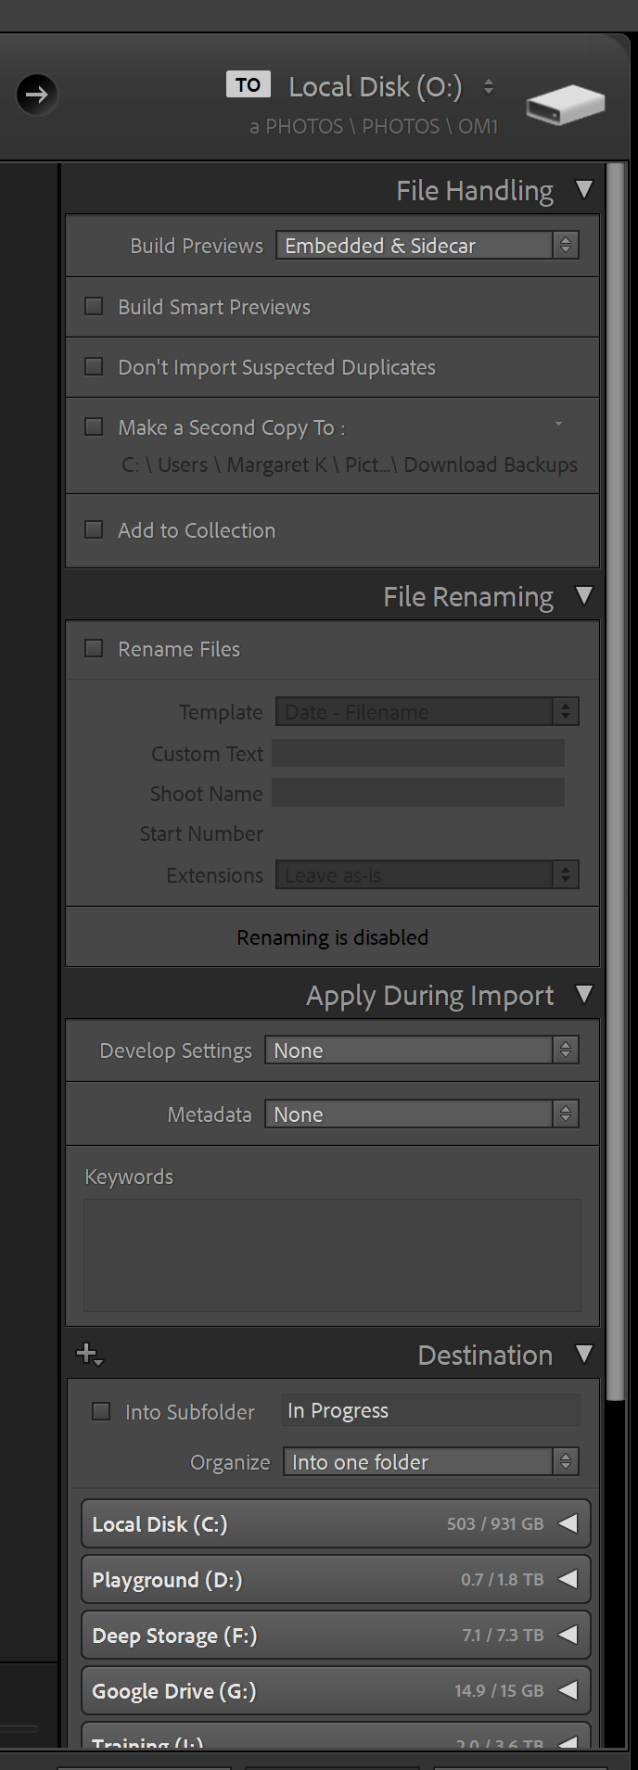
If you chose “copy” or “move” the diagram on the left shows your options.

File renaming is not available if you chose “add”. I will give you a way to rename files in a later lesson.

FILE HANDLING

Build Previews – the drop-down arrows gives the following options:
Minimal previews – take up the least space and are fastest but LR will need time to generate larger previews later in processing.
Embedded and Sidecar - If you use embedded, it just pulls the jpg from the raw data instead of converting and generating one.
1:1 previews – take the longest time to generate and take up more space but viewing and zooming will be faster.
Standard previews – a good one to use.

Other choices under File Handling allow Smart Previews (Useful if you edit photos when you are not attached to the drive the photos are on).
We will cover Collections later.

APPLY DURING IMPORT – allows developing presets, metadata presets and keywords to be added. (More on these in a later lesson).

DESTINATION
At the top of this screen on the right, there is a “TO” where you tell LR where to put new images. The Destination area at the bottom allows more choices for organising the images
Into subfolders
Use the + button to create new folders

FINALLY click the IMPORT button.

You can continue working in LR while the import is happening in the background.

LIBRARY MODULE
Once you have images in your catalogue, they are managed in the Library Module.
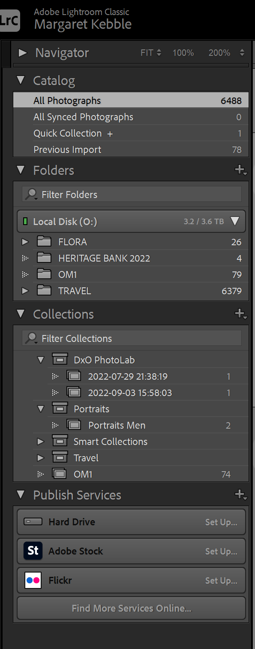
CATALOGUE
After an import LR automatically selects Previous Import and displays the images just imported.

FOLDERS
Add new folders and subfolders using the + button.
Move folders to other places by dragging them – even to other hard drives.
Move images or groups of images to different folders by selecting them and dragging them.
Rename images in the right column in the metadata tab under File Name.
Do these things in LR and they are automatically done on your hard drive. Doing the in LR enables LR to keep trac of the images.

FIND AND SYNCHRONIZE MISSING IMAGES.

When folders or images are moved outside of LR then LR will not be able to find the folder or image and an exclamation point in the folders indicates that LR does not know where it is.
Click on the exclamation point to locate missing images or missing folder.

If a folder in LR is missing previews for your images on your hard drive, right click on the folder and select synchronise folder.

VIEWING IMAGES IN THE LIBRARY MODULE

T key – toggles the tool bar on and off.

Thumbnail Size Use the -key to decrease and the = key to increase the size of the thumbnails.

G key – enables the Grid view.

Loupe view (single image) – use either the D key or the E key.

Compare view – C key – compare a selected image with other candidates. Use the arrow keys to move through them and chose the candidate you want.

Survey view N key – select two or more images to view them as a group.

In Grid View use the J key to cycle through different image information. Hover over an information badge to find out what it means.

In the Loupe view use the I key to cycle through image information.

