Daytime Portraits Using Flash and High-Speed Sync
The scene: Outdoors with full sunlight. The gear: Your camera, lens, and flash. The problem: You find that your flash only works at 1/200th or below so you need to be at f/16 or f/22 to get the shot. Everything is in focus, including all the cars and other distractions in the background. Those dust spots you keep meaning to clean are also perfectly visible. Why won’t it work with a higher shutter speed so you can have a wider aperture? Well, it’s all down to the issue of sync speed, more specifically using flash and high-speed sync.
To overpower the sun and stay below the camera’s sync speed, you’re forced to use a narrow aperture. Here I’m at f/20 just to stop the backlight overpowering the hair and the sky from blowing out. The resulting aperture means that everything is pretty much in focus, leaving the background looking cluttered. This shot is for example only, you should generally make a point of choosing clutter-free backgrounds

Sync Speed
Sync Speed is the fastest shutter speed where the camera exposes the whole frame at once. When you fire any shot below this speed, the first shutter curtain opens fully, revealing the entire sensor to light. At the end of the exposure time, the second shutter curtain moves across the frame to finish the capture. Both curtains then reset together (this means you get no light leaking in).
Generally, the sync speed varies between 1/125th and 1/250th, depending on your camera. You’ll find some quoted sync speeds are not indicated correctly. For instance, the Canon 5D series are rated at 1/200th but often show a black band at the bottom of the screen at this speed when it’s used with flash.
When you go above the sync speed, the second curtain starts to move before the first one has completed its journey. As your shutter speed gets shorter and shorter, the gap between these curtains narrows to a tiny slit. Despite this, all parts of the sensor receive light, and a full exposure is made. On a bright day, with a prime lens, you can easily shoot at 1/8000th at f/1.4 and have a perfect exposure. All parts of the frame still receive light, because it’s continuous throughout the exposure.

The Sync Speed Problem
It’s when you introduce flash that you start to have problems. You see, when a flash is fired (usually when the first curtain is opened) all the light from it comes out in a very short space of time (in order of milliseconds). When you go above (faster than) the sync speed, the position of the curtains doesn’t reveal the entire frame at the time the flash fires. The means the shutter curtain blocks part of the flash and prevents it from reaching the sensor. Any ambient light will expose normally, but the flash gets hidden in part of the frame. As your shutter speed gets faster and faster, more and more of the flash is blocked until it’s no longer visible in the shot.
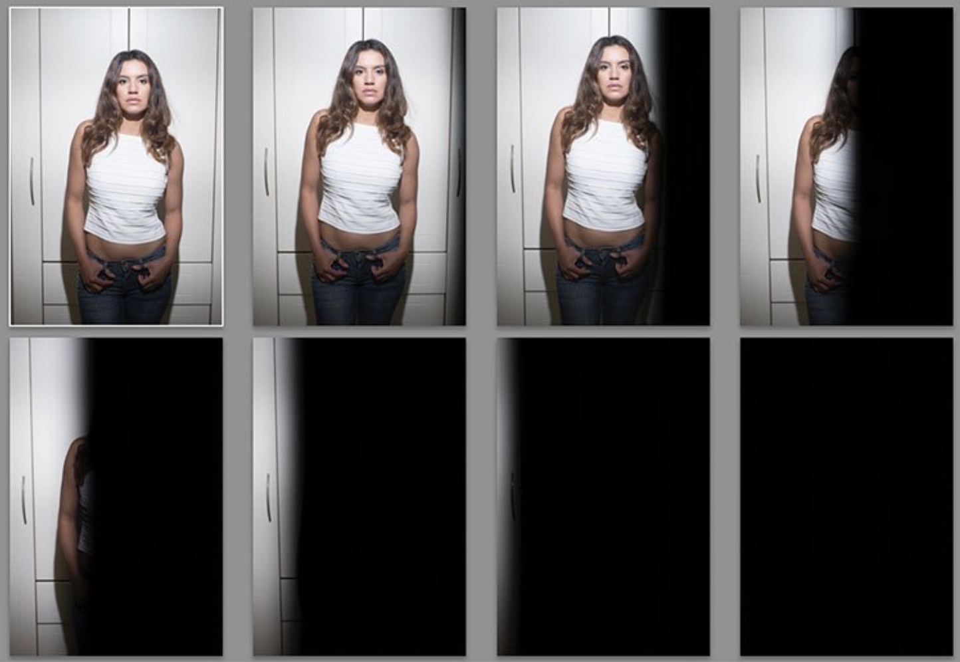
Here’s a set of images taken at 1/3 stop increments with a flash. The first is at 1/250th, the native sync speed of the camera. In order (left to right, top to bottom) 1/250th, 1/320th, 1/400th, 1/500th, 1/630th, 1/800th, 1/1000th, and 1/1250th. Even 1/320 is useable if the subject being lit is away from the edge.

Everything in Focus
Normally when you use flash outside in daylight, you end up having everything in focus. Remember the Sunny f/16 Rule? If your subject is in direct sunlight during the day, you can set your aperture to f/16 and your shutter speed will be one over your ISO value. So, if your ISO is set to 100, your shutter speed would be 1/100sth (and f/16). As another example, if your ISO is 200, then the shutter speed would be 1/200th. To get a richer sky, you’d really need to be at f/22, making it a tough job for your flash. Because you can’t get faster than 1/250 (sync speed), you have to increase the aperture to expose the shot correctly.

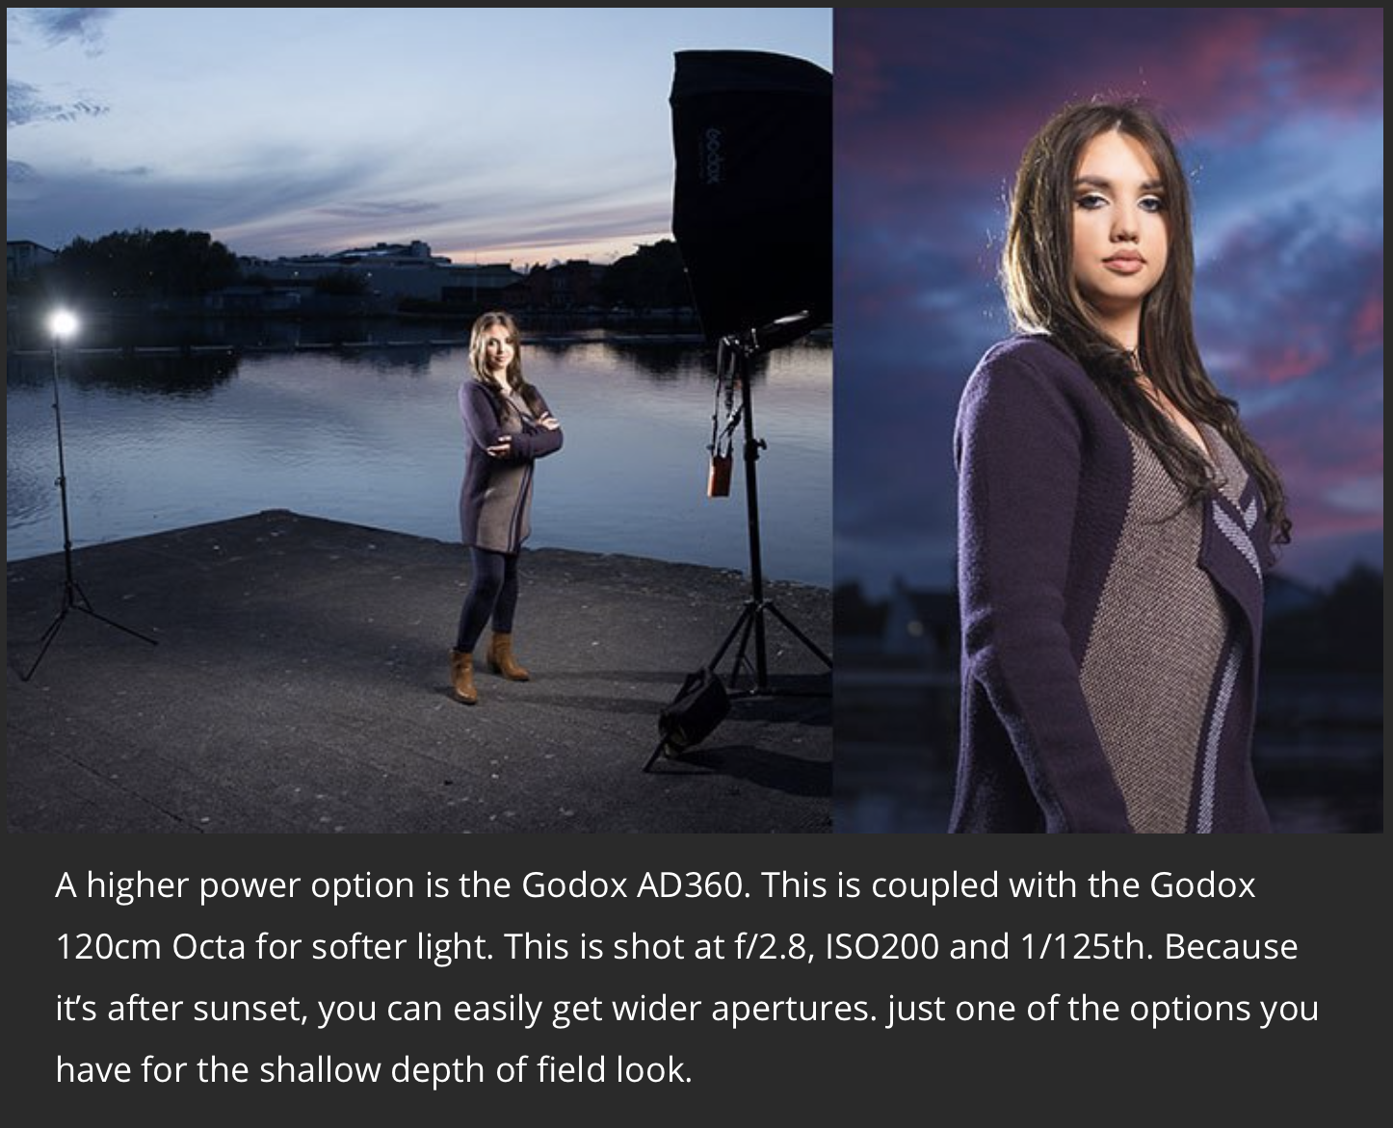
Softer light
Most speedlights at full power, bare bulb, in close, can give you just enough power to look natural at these settings. Bare flash is not flattering, though it can add character. If you want softer, more flattering, light, you need more power. Most modifiers that give soft light will take two stops of power compared to the bare flash. That’s a lot of power. You could use a more powerful light, like the Godox AD360, the Elinchrom Quadra, or the Profoto B1. Alternatively, you could use a bracket that takes multiple speedlights. Either option allows you to get soft, flattering, light while outdoors.

The Solution: High-Speed Sync
You’ll need to find a way to get around the issue of sync speed for daytime shooting. Fortunately, there is a solution. It’s not perfect, but it does work. It’s called High-Speed Sync, also known as Focal Plane Sync. High-Speed Sync (HSS) works in a unique way. Instead of firing the flash at the start of the shot, HSS pulses the flash throughout the whole exposure, trying to simulate the effects of a continuous light.
It works well, but it comes at the expense of power, and heat. HSS works the flash really hard. After a few shots, the flash may even shut down for cooling. For HSS to work, you need the camera to transmit HSS to flash, and for the flash have HSS built in. All major brands allow it. Many companies make triggers which allows you to use any HSS flash with any camera. When you look at a flash, ask if it has HSS or Auto FP capability.

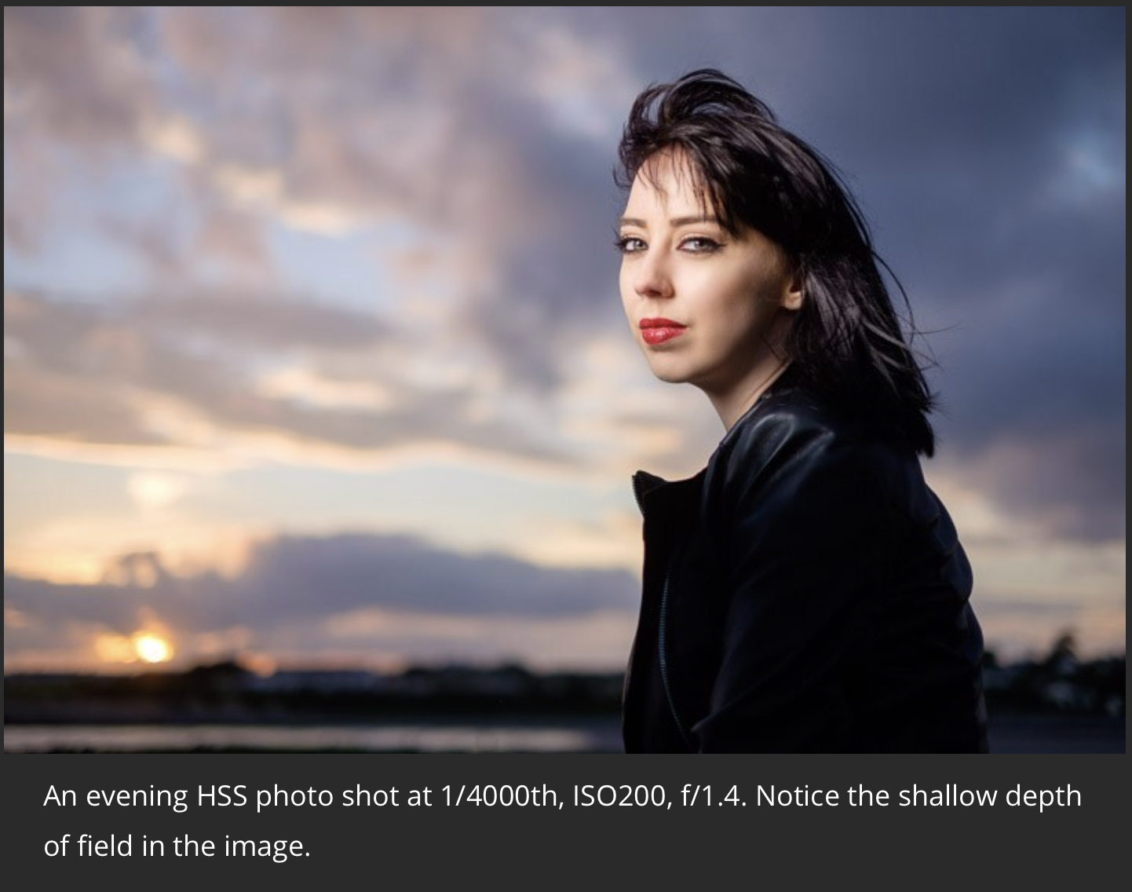
Settings for High-Speed Sync
Let’s look at a typical setup and settings for a shoot using HSS. This shoot happened to be done on an evening, but I really wanted shallow focus. The camera was set to f/1.4 for super shallow depth of field. To get the clouds properly exposed, you’ll have to drop the shutter speed to 1/4000th. To get the flash (an AD360) to work you have to set it to HSS (or FP on some).
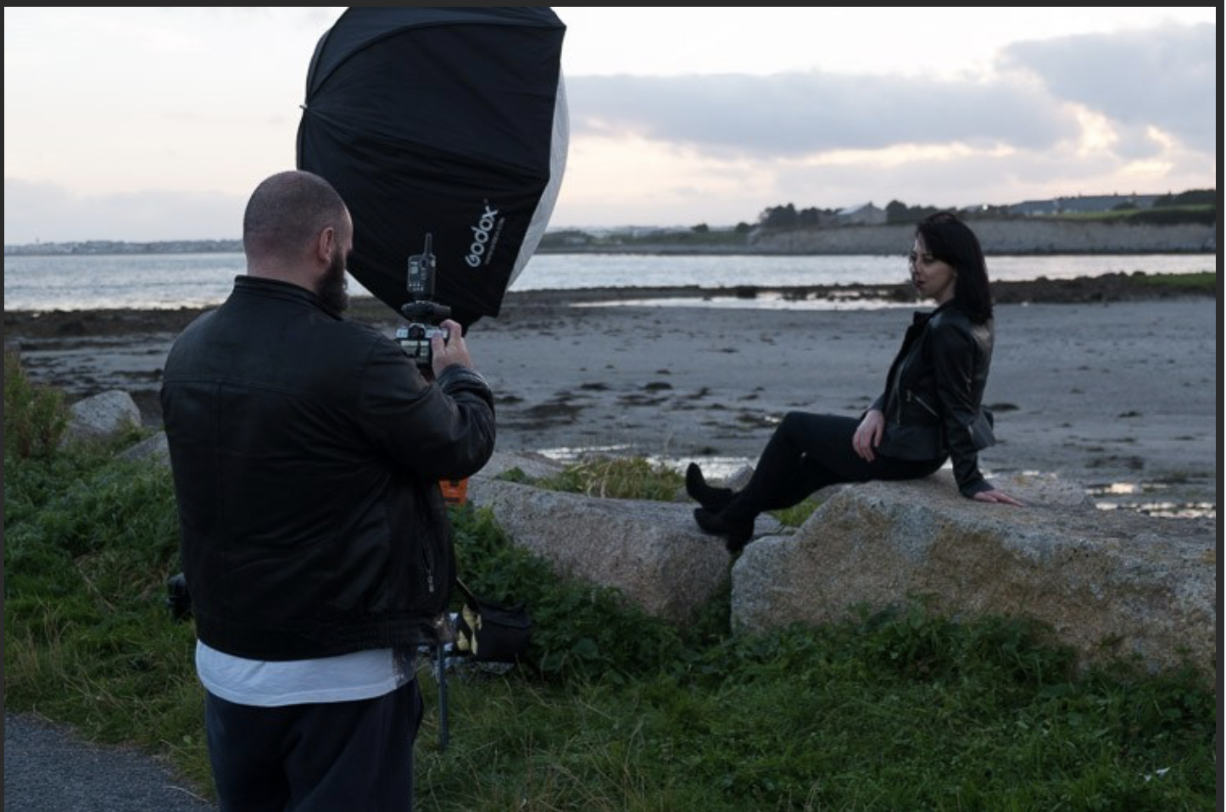

The Alternative
High-Speed Sync isn’t the only way, you’ve got other options. The first has been mentioned. Shoot at the beginning or end of the day. You can get great sky colour and you’re not fighting strong sunlight. Of course, if you’re doing any work, even as favours, you often have to work to the subjects’ schedule rather than your own. So, you may have to shoot at midday to suit them. That leads to the next option.

Using Neutral Density Filter
If you shoot landscape photography, you will be familiar with Neutral Density (ND) filters. This filter allows you to slow the shutter speed down to get nice silky water. Neutral means that it adds no colour, while the density part refers to blocking light. You can get them in a range of values from 1 stop to 16 stops.
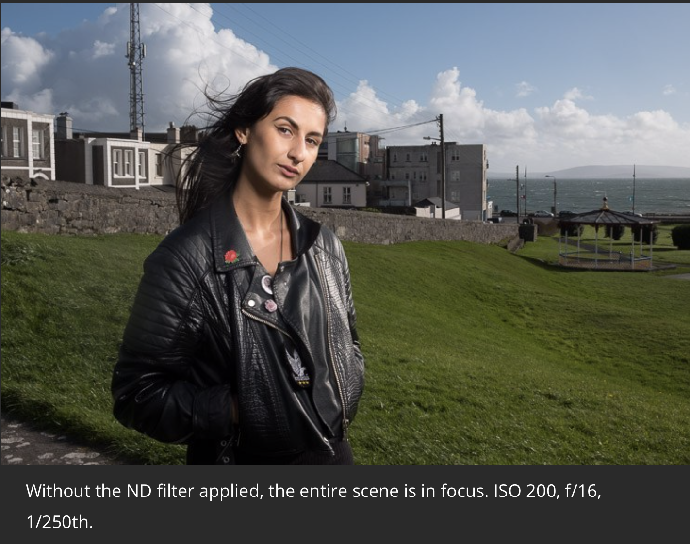
For portraits, these allow you to drop the aperture down instead of shutter speed. So, a 4 stop ND would take you from f/16 to f/4. The drawback is that as you block light, focusing can become harder. Another potential issue is that not all ND filters are actually neutral. Some tend to have a colour cast. You can either use spin-on filters for flat faced lenses or square filters for both flat front optic lenses or bulbous wide angle lenses.
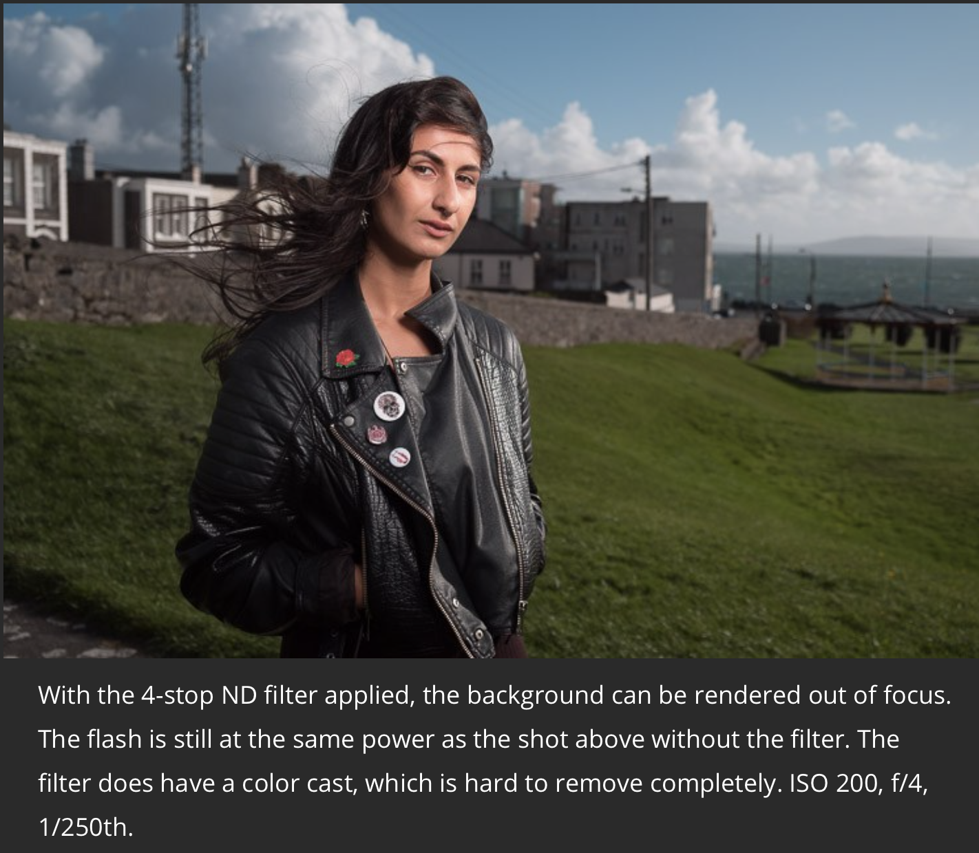
I would suggest this is the last and most difficult method to achieve great art given any outdoor lighting circumstance. But, with practice this can achieve the look you are after.

A flash that shoots FP/HSS is a wonderful addition to your kit, they give much flexibility and allow you to keep shooting in strong mixed lighting conditions where others are left to have very overblown backgrounds with a correctly exposed subject.

