Night Sky and Astrophotography

To take your star pictures, you only need three things:
- a camera that the shutter can stay open (for 15-25 seconds)
- a fisheye or wide angle lens (for the widest view of the sky)
- a tripod (for stability during open shutter photos)
Camera Settings
You can nail this shot almost every time with these settings: 25 second exposure, f/2.8, ISO 1600
If your lens doesn’t open up to f/2.8 you can try 30 seconds at f/4 with ISO 1600. The compromise here is that the stars may have some coma (movement effect) with this slightly longer shutter setting.

Why to use these settings
The most important component of these settings is the 25 second exposure. An exposure longer than about 25 seconds will start to show star trails. Photographing star trails is a legitimate type of photography on its own, but not the type of photography you are trying to do here.
Since you are limited to about 15-25 seconds max shutter speed, you still need to let in more light. The largest aperture you can find on a fisheye lens is f/2.8, and still your picture might not be quite bright enough to look stunning. So, this is where the ISO comes into play. On a full-frame camera like the 5D Mark III or the Nikon D850 you can bump the ISO up to around 2000 without seeing much noise. Learning how to reduce noise in post-production is the next step for a super clean photo.
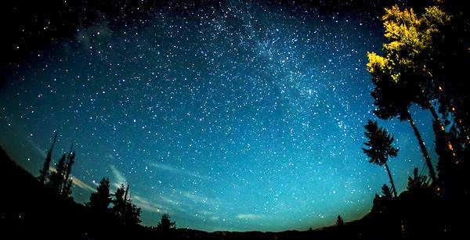
25 Seconds at f/2.8, ISO 1600

Editing in Lightroom
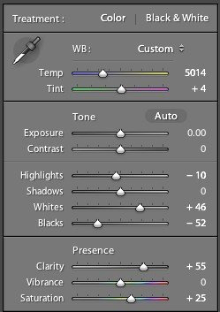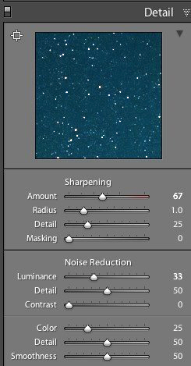

1) You can see in the first panel that the whites are bumped up to +46 and the blacks brought down to -52, to emphasize the stars against the dark sky and this is a good way to do that. Pushing the clarity up to +55 also helps define the stars against the sky, making them nice and crispy. The saturation is boosted to bring out any colours that are in the sky.
2) In the second panel you can see that it is sharpened up the a bit, also to emphasize the stars. At the same time, the noise reduction is around 33 to smooth out some of the noise that might show up, and the colour is brought up to 25 for the same reasons.
These are not absolute measurements or settings, just a good starting point before you refine your own.

Pro tips
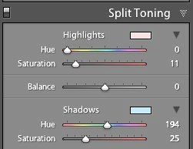
Here is where you can have fun with the editing. Play around with the split toning sliders to make the colours in your sky appear magical. In the photo above you can see a little bit of turquoise in the lower part of the sky, and that comes from boosting that colour in the Shadows of the Split Toning slider here:
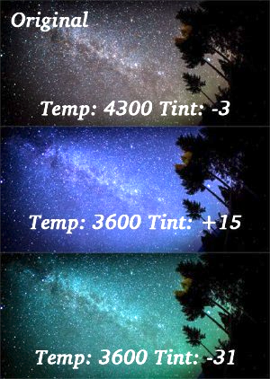
You can also affect the colour of the sky by playing around with the temperature and hue sliders to get some pretty magnificent looking star photos. Take a look at this one photo rendered three different ways:
Another pro tip that you may have noticed in all of the photo examples given here is this – shoot your stars in context. It really tells a great story to see a silhouette of a pine tree or a house in the background, and it shows the magnitude of the scene when you have an object in the foreground to compare to the stars.
Lastly, make sure you know which direction the Milky Way is. You can use an app like Sky Map to see exactly what stars are in the sky above you.

Light up the foreground
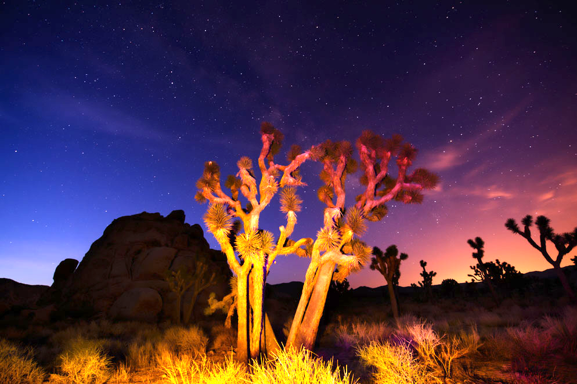
Using a wide-angle or fisheye lens, you can also incorporate the foreground into your images. Depending upon the subject, the foreground as a silhouette may enhance the overall image, or detail in the foreground may complement the night sky. The foreground can also be lit using a variety of techniques.
High Dynamic Range (HDR): One technique is to take multiple shots, bracketing or varying the actual exposure time, and merge them as HDR which you can composite with the final image of the properly exposed sky.
Painting with Light is another technique that can be used if the foreground is close enough. There are two ways to paint with light: using a constant light source such as a flashlight or with a Speedlight.
Constant light source: while the shutter is open, use a constant light source to illuminate the foreground. Move the light around during the entire exposure so you don’t end up with hot spots.
Speedlights: while the shutter is open, press the Speedlight’s Flash button. As with the constant light, move the Speedlight across the scene to allow the flash to illuminate the entire foreground.
And just because there are clouds in the sky doesn’t mean you need to stay indoors. The clouds can add an interesting aspect to night photography when they’re sparsely dotting the sky, allowing the stars to peek through.

Tips for Night Sky Photography:

- Look for cool clear moonless nights (unless you specifically want to photograph the moon!) and avoid light polluted areas (big cities or towns).
- Start with fresh, fully charged batteries.
- Use a sturdy tripod and cable release; set up your composition, lock down the focus, and make a test shot. This will help determine exposure, and if you need to make any changes to your composition.
- Shoot NEF (RAW) so you can more easily make adjustments in post-production if needed.
- Set the white balance between 2800°K-4000ºK. Check the histogram after you take the picture to make sure the image is being properly exposed. It’s easy to underexpose the stars or overexpose a foreground.
- Zoom in to the image on the LCD to check sharpness.
- Consider making a series of exposures for the foreground to merge as an HDR composite with the stars.
- A good starting exposure for most star shots is to use the widest aperture on your lens, expose for 20 seconds, increasing the ISO as needed for a good exposure.
- If you’re going out to specifically shoot the moon, research the phases of the moon, so you know what time the moon will be rising and setting each evening, so you know when to plan your shoot. Also note the direction it will travel in the sky to plan your composition.
- Turn ON the camera’s Long Exposure Noise Reduction feature.
- Silhouetted foreground features can look really cool, look at the image below!

